Visualizing Global Population Growth Trends
Introduction
In this project, we aim to visualize a global insight into population growth over time, emphasizing the urgent concerns of resource scarcity and environmental impact that accompany this trend. As population numbers climb, so too does the demand for essential resources like food, water, and energy—pressures that are particularly critical in densely populated and resource-limited regions. By examining shifts in population distribution, age structures, and growth rates, this project seeks to draw a comprehensive "big picture" to illuminate how population dynamics exacerbate resource scarcity and drive environmental degradation.
Through diverse data visualization techniques, we provide insight into the patterns behind population growth, its regional disparities, and the associated demands on resources and sustainability. This analysis highlights the importance of understanding where populations are densest, how age structures shape resource needs, and what future growth means for environmental stability. These visualizations collectively aim to clarify why resource scarcity and environmental impact have become central concerns in discussions about population growth.
To illustrate these dynamics, we will use the following visualizations:
- Global Population Density: A choropleth map to highlight high-density regions, emphasizing areas where resource demand is likely to strain existing supplies.
- Population by Region Over Time: A stacked area chart to illustrate regional population growth, showing where rapid increases are putting pressure on local ecosystems and resources.
- Historical Population Growth Rate: A line chart to trace changes in the global growth rate over time, contextualizing when growth rates intensified and began impacting resources.
- Birth and Death Rates: A line chart showing annual births and deaths, helping readers understand population momentum and the resulting pressures on food, water, and infrastructure.
- Fertility Rates by Region: A line chart to show regional fertility rates, underscoring where high fertility continues to drive growth and heighten demand on environmental resources.
- Age Group Distributions: A stacked area chart breaking down populations by age group, visualizing demographic pressures on resources like healthcare and social services.
- Future Projections: Using UN projections, line and area charts to illustrate expected future trends, giving a clear picture of the challenges in balancing population growth with environmental and resource sustainability.
These visualizations aim to create a multidimensional view of population growth, helping readers understand the profound impacts on resource availability and environmental health, and why managing these aspects is critical for sustainable global development.
User
The target users for this project include policymakers, demographers, researchers, educators, and anyone interested in the global implications of population growth and resource management. This project is designed to serve a broad audience by presenting complex data in an accessible and intuitive format, allowing nonexperts to grasp key insights while providing the depth needed for thorough analysis by specialists. These visualizations can support informed decision-making, offering valuable perspectives for resource allocation policies, urban planning, international development, and sustainability strategies. By engaging this wide range of users, the project aims to contribute to better policy outcomes and heightened awareness of the critical issues surrounding population growth.
Website
The most pressing concern related to population growth globally is resource scarcity and its environmental impact. This issue is at the heart of many interconnected challenges and affects both immediate needs and long-term sustainability. But why?
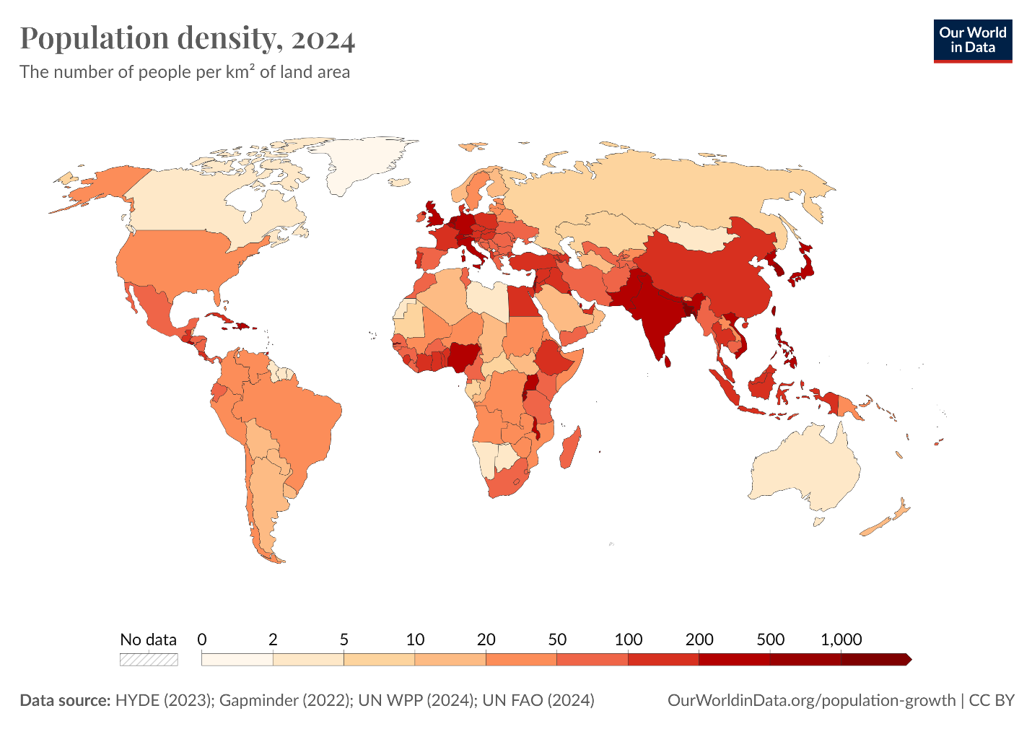
Figure 1 Choropleth Map of Global Population Density
- Insight: A choropleth map effectively shows how populations are distributed worldwide, highlighting regions with high density versus those with sparse populations. This map visually underscores where resource demands are likely to be highest, given population concentrations.
- Reader Takeaway: This provides a geographic overview, allowing readers to identify the regions facing the greatest pressure for essential resources (e.g., food, water, and energy).
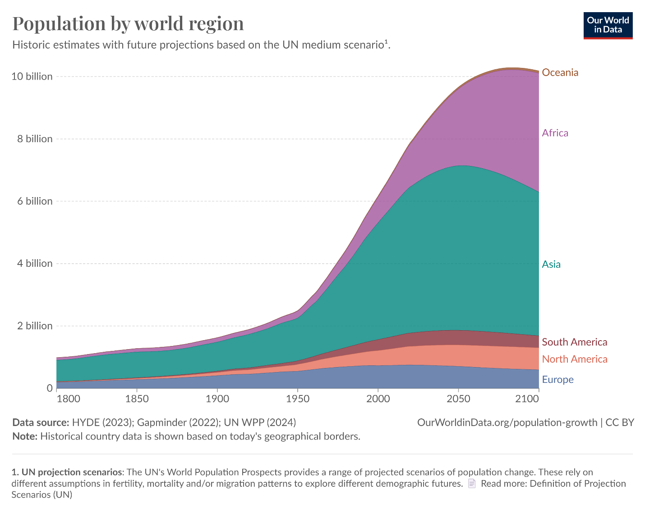
Figure 2 Population by Region Using Stacked Area Chart
- Insight: This chart can display how populations have grown across various world regions over time. It allows for comparisons between regions, showing where growth is most rapid (e.g., Africa, Asia) versus where it has stabilized or slowed (e.g., Europe).
- Reader Takeaway: This visualization captures the historical and projected growth of different regions, emphasizing the need for regional policies to manage growth-related challenges effectively.
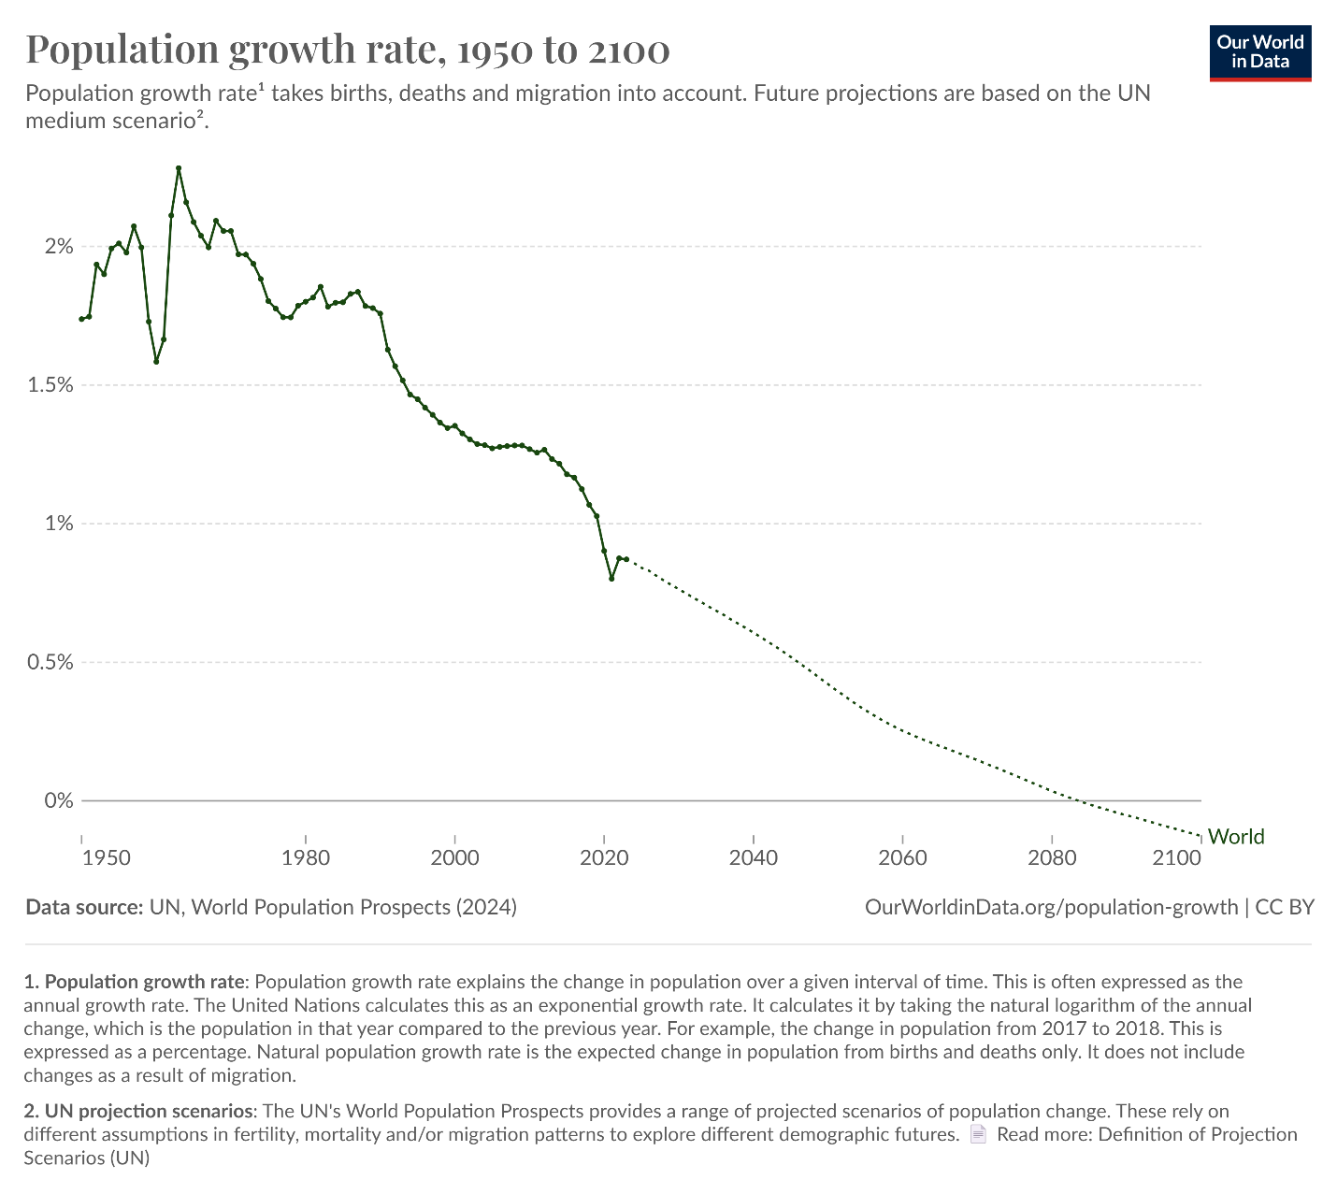
Figure 3 Population Growth Rate Over Time Using Line Chart
- Insight: Showing population growth rate as a line chart highlights peaks (e.g., the 1960s) and the gradual decline in growth rate since then. This demonstrates that while the total population is increasing, the pace of growth has slowed.
- Reader Takeaway: This chart gives a long-term perspective on how quickly (or slowly) the population is growing, providing context for sustainable development goals and strategies.
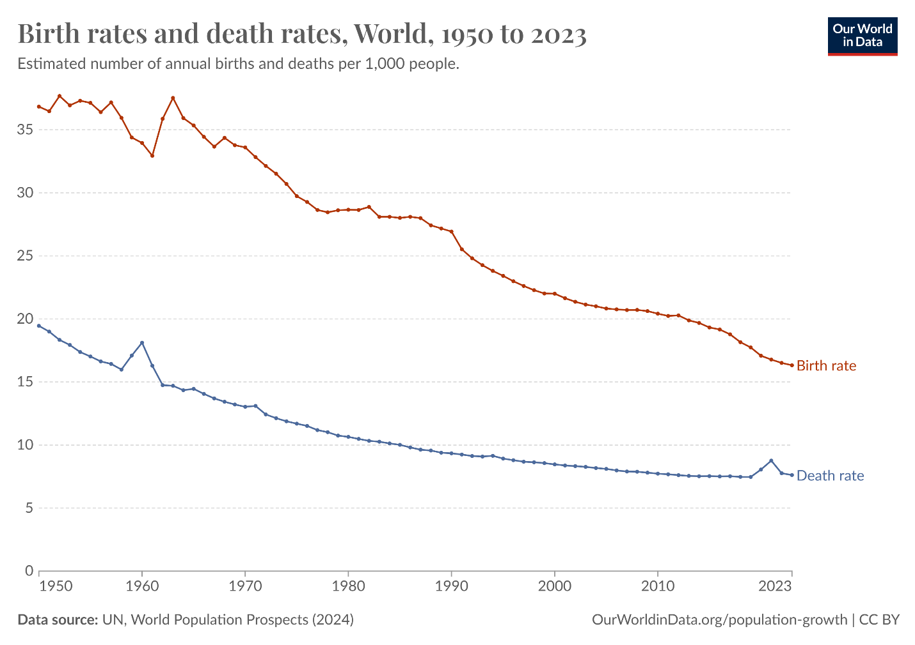
Figure 4 Births and Deaths Per Year Using Line Chart
- Insight: This chart shows the annual number of births and deaths, illustrating the population's natural increase or decrease. It’s especially relevant for showing demographic transitions and how they differ across developed and developing regions.
- Reader Takeaway: Readers can understand how births and deaths affect the natural population growth rate, offering insights into aging populations and regions where high birth rates continue.
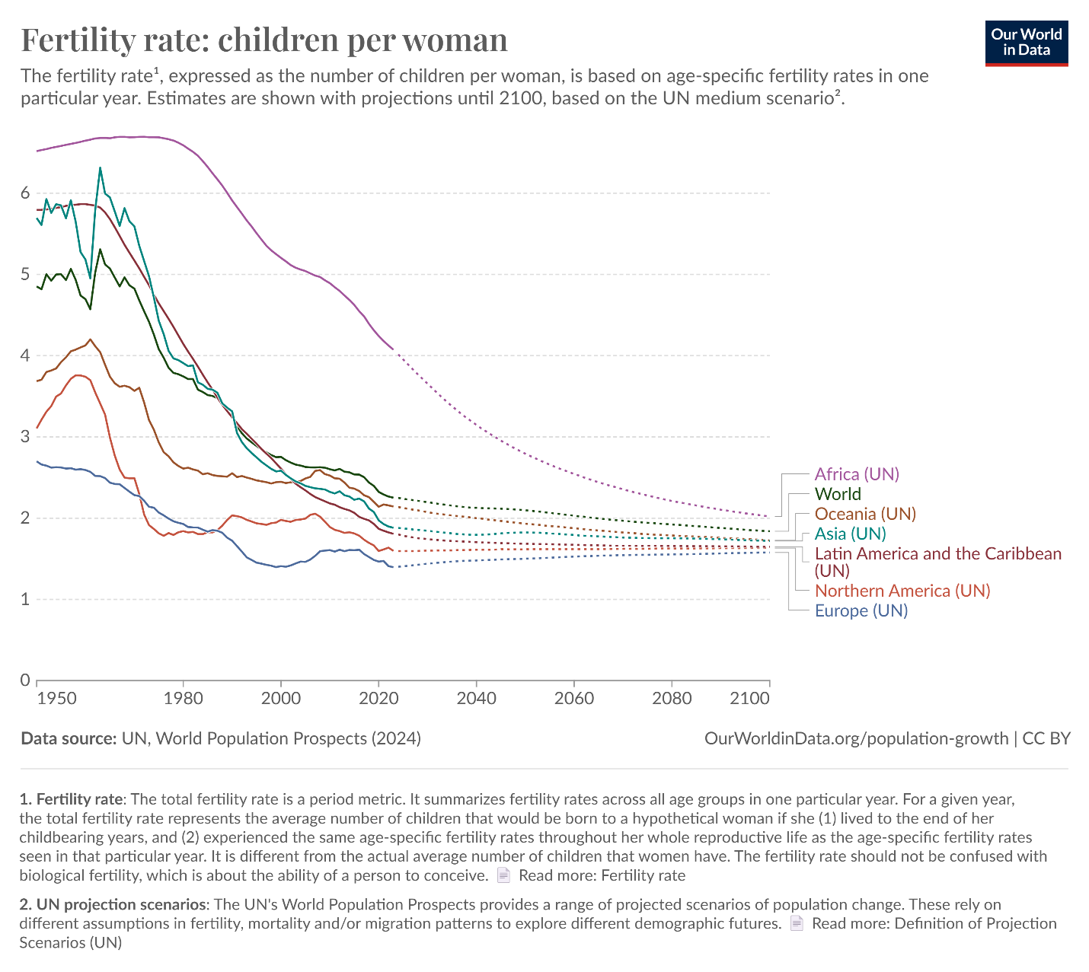
Figure 5 Fertility Rate (Children per Woman) by Region Using Line Chart
- Insight: Fertility rate data is essential for understanding long-term population growth and potential decline. This chart can highlight regions with high fertility (often in less developed areas) versus those with lower fertility (often in wealthier nations).
- Reader Takeaway: It helps readers understand how fertility affects population growth in the future, spotlighting areas where high fertility rates may drive ongoing growth and resource demands.
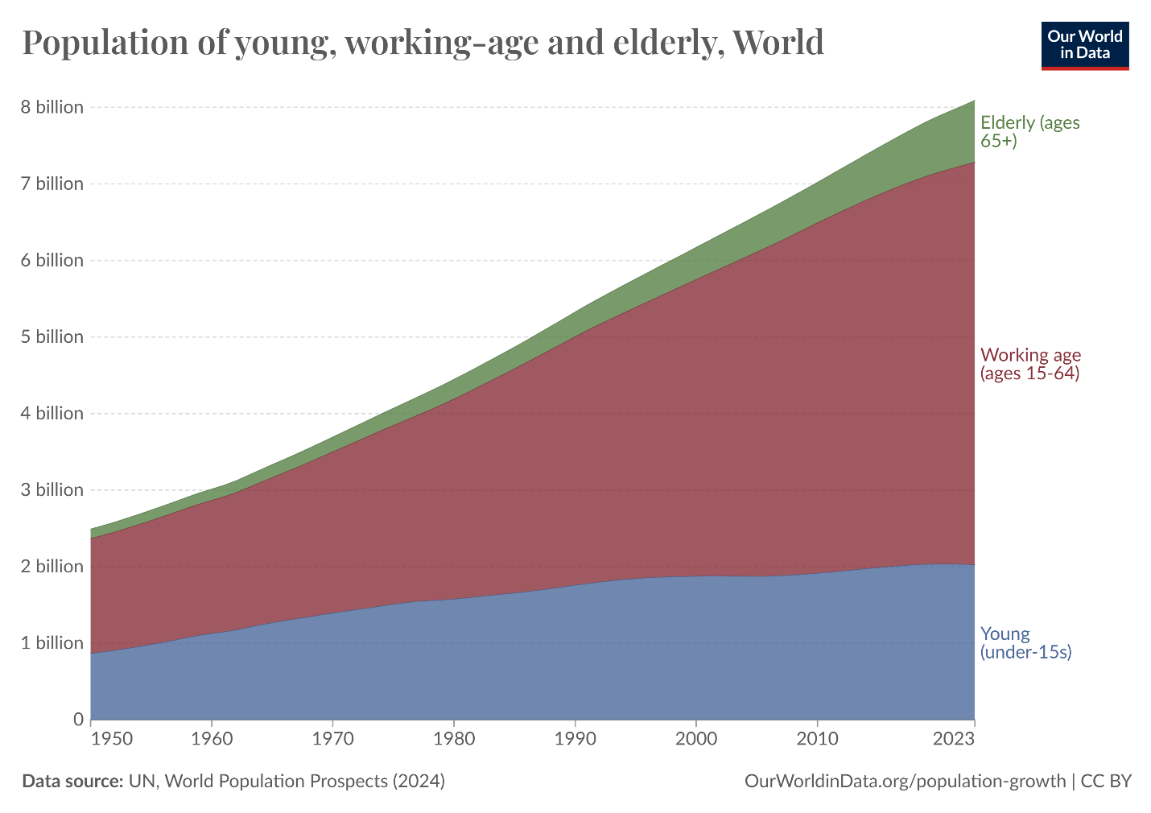
Figure 6 Population by Age Group (Young, Working-Age, Elderly) Using Stacked Area Chart
- Insight: A breakdown of population by age groups shows the demographic structure of the global population, which is crucial for understanding economic pressures, such as aging populations and youth bulges.
- Reader Takeaway: This chart provides insight into future workforce sizes, dependency ratios, and potential societal pressures, such as healthcare and pension demands.

